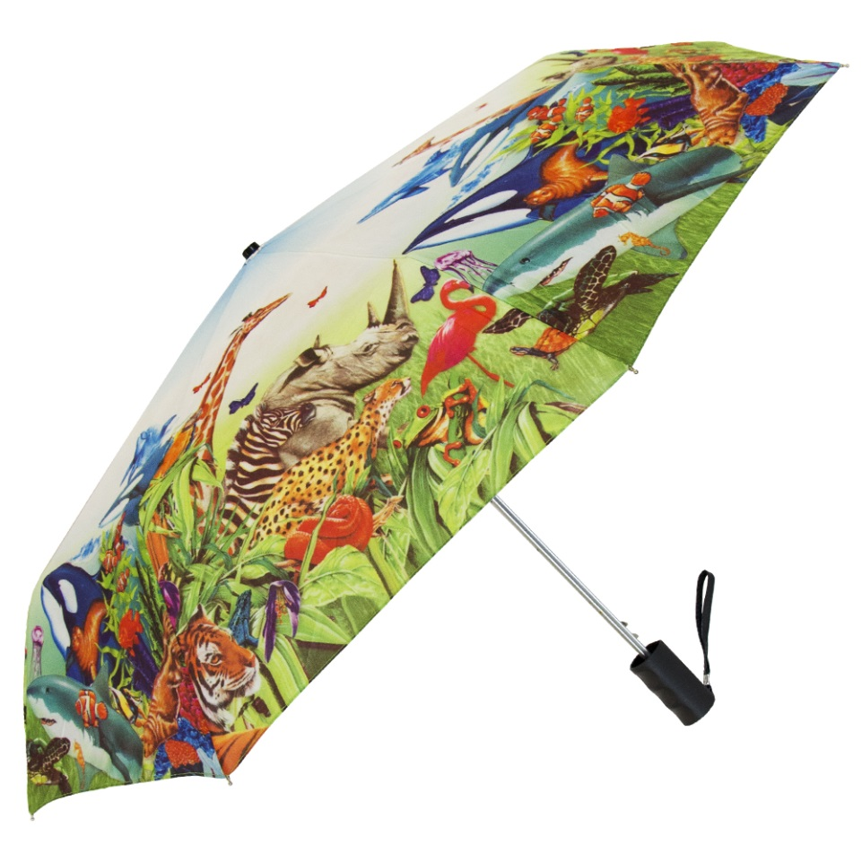
SB-6121-S (Formerly Item# DIG-85EZW-S)

Full-Color Canopy Printing - Single Canopy

With our Full-Color Canopy Printing program we digitally print designs and images on entire canopies at a low minimum, price and turnaround. This Single Canopy option is modeled after our Windproof Umbrella (SB-1210) and allows for full-color top canopy printing.

Arc Size: 42” Number Of Panels: 8

Diameter: 38” Length When Closed: 15”

Opening: Automatic Imprint Area: 5”H x 7”W

Shipping weight 48 pieces: 38 lbs. Box Dimensions: 20” x 7” x 17”

